**Species Distribution Models of Threatened Bats using Maxent**

**and ArcMap in Global Biodiversity Hotspots**

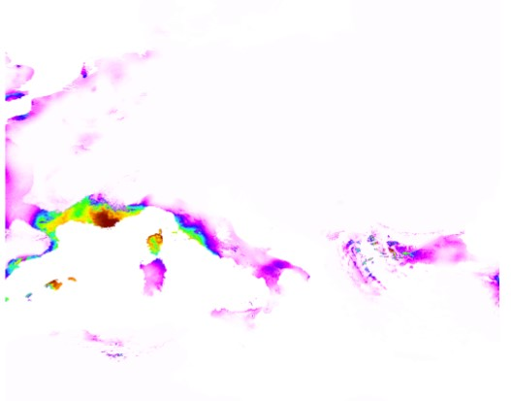

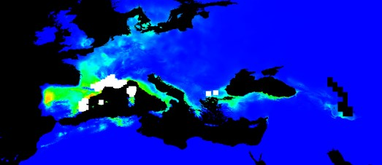

**1. Introduction:** Bats make up over one-fifth of all mammals on the planet, and it is estimated that over 30% of all bat species are threatened or data deficient. Migratory species such as bats remain poorly understood because of their broader diversity and range of global habitats that they occupy. Bats play an important role in insect management, agriculture and even medicine, and their populations are dwindling due to various anthropogenic impacts such as wind turbine development, human-induced climate change and deforestation. But, we lack the data to make impactful adaptive management plans. This is particularly true for global biodiversity hotspots (or regions with a large number of vascular plant endemics and reduced natural vegetation) where conservation prioritization is sorely needed in order to combat extinction risk. Species Distribution Modeling is an effective way to predict species richness based on current and future trends of environmental variable and can help provide guidance for future adaptive management. **I will generate species distribution models of threatened bats species using various eco-geographical variables in global biodiversity hotspots in order to prioritize areas for conservation.** The first aim is to determine significant eco-geographical variables for i) climate change and ii) use species distribution modeling to predict future bat species richness in global biodiversity hotspots. The second aim is to determine which hotspots have a high prioritization for conservation based on ecological niche modeling. These models will be useful for future decision making in natural resource management to better manage bat habitats.

**2. Methods and Materials:**

***2.1 Study Area***

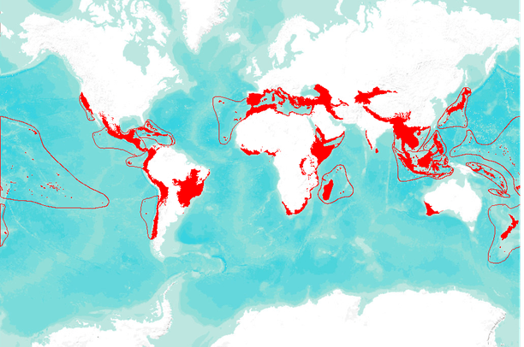

**Fig. 1.** Global Biodiversity Hotspots

Areas of interest: The Mediterranean Basin and the Irano-Anatolian region (Fig 2).

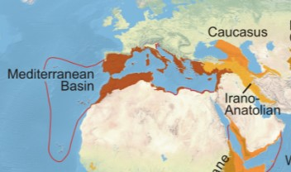

**Fig. 2.** Areas of study

***2.2 Methods***

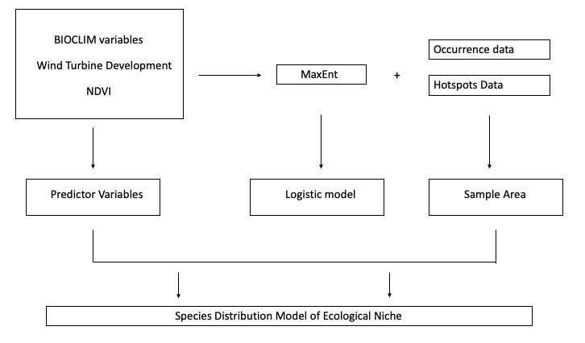

**Fig. 2.** Workflow for Species Distribution Model

Ecological Niche Modeling (Figure 2) was used in this study to model threatened bats current and future (2050 and 2070) ecological niche.

***2.3 Occurrence and Hotspot Data***

A total of 209 bats were identified as threatened ("Vulnerable," "Endangered," and "Critically Endangered" status) according to records from the International Union for Conservation of Nature (www.iucnredlist.org. Accessed November 4, 2019).

Of these, 128 species of bats had known occurrence records (decimal Latitude and Longitude) and these were exported and converted into point data in ArcGIS 10.7.1.

Hotspots were uploaded as point feature classes and converted into polygon feature classes using the

***2.4 Extent***

All variables for Bioclim and Vegetation were cropped to within 1 degree of extent for the sample size (e.g. xmin-1, xmax+1, ymin-1, ymax+1).

***2.5 Environmental Variables***

19 BIOCLIM variables were downloaded from WorldCLIM (worldclim.org/version2, 1960-1990 averages) and converted from 30s raster (0.5 res) (.tif) files to ASCii (.asc) format using the raster, maps and mapdata libraries from R (World Geodetic System 1984, WGS84).

The Global Climate Model (GCM) for the National Center for Atmospheric Research Community Climate System Model version 4 (CCSM4-code “CC”) was used for all data.

Climate Research Programme’s Coupled Model Intercomparison Project phase 5 (CMIP5) protocol for predicting future carbon concentrations were downloaded from <https://www.worldclim.org/cmip5_30s> at 30 s resolution.

***2.6 MaxEnt Software***

Version 3.4.1 was used to model predicted species distribution for current and future scenarios for CO2 concentration (RCP 45 2050/2070 and RCP 85 2050/2070). Decision thresholds for minimum (0% omission rate) training presence were redrawn in R as a binary prediction where 0 (range 0-0.011, “unsuitable”) or 1 (range 0.011-1, “suitable”). Similarly, thresholds for 10th percentile (10% omission rate) training presence were redrawn as 0 (0-0.262, “unsuitable”) or 1 (0.262-1, “suitable”).

The reclassify function in R was then used to

***2.7 Global Vegetation Layer***

ArcMap 10.7.1 was used to convert 12 classes of global land cover data (<https://www.earthenv.org/landcover> at 1-km spatial resolution from geotiff (.tif) to shapefiles (.shp) using WGS84 (Table 1.). For rapid display at varying resolutions, used Nearest Neighbor Interpolation (weighted “stealing” values of closest subset of input values). I used class 7 and 11 to describe human influence on vegetation.

**Table 1. 12 classes of global vegetation at 1-km spatial resolution**

|  |  |
| --- | --- |
| 1. Evergreen/Deciduous Needleleaf Trees | 7. Cultivated and Managed Vegetation |
| 1. Evergreen Broadleaf Trees | 8. Regularly Flooded Vegetation |
| 1. Deciduous Broadleaf Trees | 9. Urban/Built-up |
| 1. Mixed/Other Trees | 10. Snow/Ice |
| 1. Shrubs | 11. Barren |
| 1. Herbaceous Vegetation | 12. Open Water |

**3. Results and Discussion**

**Specific Aim 1: Determine significant current and future variables for i) climate change and ii) use species distribution modeling to predict future bat species richness in global biodiversity hotspots.**

*Current Bioclim variables (Presence only):*

Of 128 known occurrence records, there were only 2 threatened bats (*Myotis Capaccinii*, and *Nyctalus Lasiopterus* that gave a readable output for all 19 bioclim variables:

Both *M. Capaccinii* (the Long-Fingered bat) and *N. Lasiopterus* (the Giant Noctule bat) are listed as Vulnerable according to the IUCN Red List ([www.iucnredlist.org](http://www.iucnredlist.org), Accessed November 29, 2019).

**Table 2**. *Myotis Capaccinii*. Logistic Threshold for Minimum training presence (“unsuitable” 0-0.008, “suitable” 0.008-1) and 10th percentile training presence (“unsuitable 0-0.380, “suitable” 0.380-1). Based on 110 presence records.

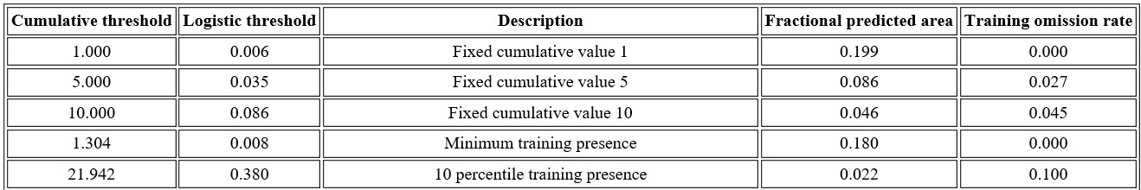

**Table 3**. *Nyctalus Lasiopterus*. Logistic Threshold for Minimum training presence (“unsuitable” 0-0.041, “suitable” 0.041-1) and 10th percentile training presence (“unsuitable 0-0.179, “suitable” 0.179-1). Based on 34 presence records.

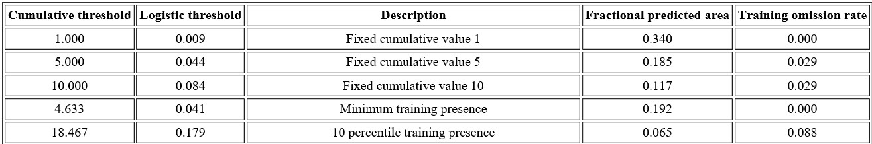

*Current BioClim Permutation Contribution:*

The bioclim features that were most important to make predictions for *M. Capaccinii* were Precipitation of the Driest Month (bio14, value=46.3) and Precipitation of the Driest Quarter (bio17, value=17.7). For *N. Lasiopterus* they were Temperature Seasonality (bio4, value=52.4) and Annual Mean Temperature (bio1, value=19.6).

*30% Random Test Data for Training (Calibration) and Testing (Evaluating):*

The contribution of each variable is determined by random permutation of its values among training points (presence and background). The test data is the resulting decrease in Area Under the Curve (AUC).

*Myotis Capaccinii*

Based on 30% test data and a minimum training threshold, the omission rate was 0.030 (binomial test p<0.05).

AUC based on 30% test data = 0.965 (sd=0.011).

*Nyctalus Lasiopterus*

Based on 30% test data and a minimum training threshold, the omission rate was 0.000 (binomial test p<0.05).

AUC based on 30% test data = 0.901 (sd=0.010).

Figure 3

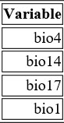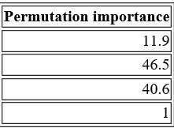

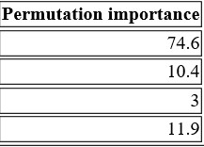

1. M. Capaccinii b. N. Lasiopterus

**Figure 3a and b.** Permutation importance was based on random 30% omission training data.

Figure 4 represents the Sensitivity Analysis for Training (0% omission) and Test (30%) omission for *M. Capaccinii* and *N. Lasiopterus.*for BioClim variables 1, 4, 14, 17.

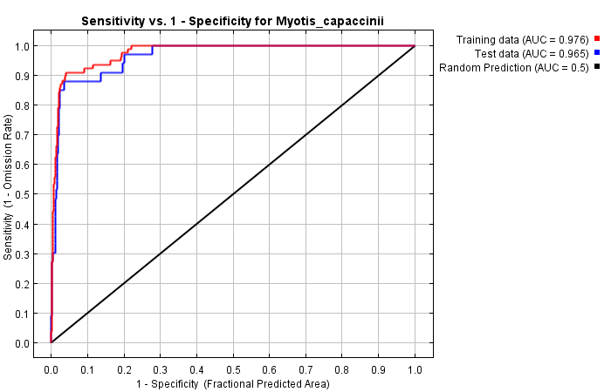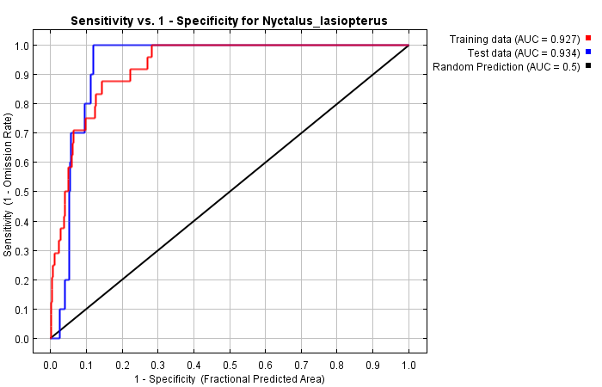

**Figure 4. MaxEnt Data.** *Myotis Capaccinii.* Based on 30% test data and a minimum training threshold, the omission rate was 0.030 (binomial test p<0.05).AUC based on 30% test data = 0.965 (sd=0.011). *Nyctalus Lasiopterus*. Based on 30% test data and a minimum training threshold, the omission rate was 0.000 (binomial test p<0.05). AUC based on 30% test data = 0.901 (sd=0.010).

**Specific Aim 2: Determine which hotspots have a high prioritization for conservation based on ecological niche modeling. 2.1** Examine predicted bat distribution and the correlation between human-related variables to a) determine which variables lead to a greater decline in species richness and b) which global hotspots are at a greater risk of reduced bat populations.

*Global Vegetation:*

Figure 3 illustrates the current distribution of threatened bats in areas that have high levels of managed vegetation (Class 7), Urban Build up (Class 9) and Barren Areas (Class 11).

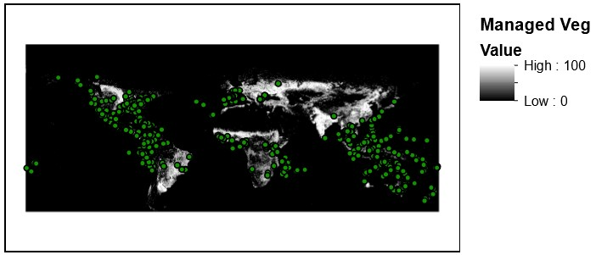

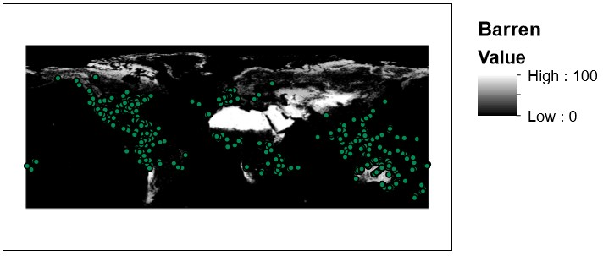





**Figure 3.** Areas of threatened bat concentrations at 1km Global Land Cover Class 7, 9, 11 (created in ArcMap).

**4. Conclusions**

According to Figure 3, the Management vegetation concentrations depicts that threatened bats are not aggregating around cultivated areas. This is an indication of common needs for habitat between the two species, as *N. lasiopterus* (Alcalde, 2016) roosts in forest and shrubland in the Irano-Anatolian region, while *M. Capaccinii* (Paunovic, 2016) also resides in shrubland, but prefers to forage over wetlands and waterways. In this instance, both wetlands and shrubland need to be considered at environmental predictors.

The AUC for Figure 4 remained above the 90% percentile for both 0% and 30% omission training data for both species. This indicates that the bioclim variables chosen (1, 4, 14, 17) are good predictors of species distribution for these two bats.

Greenhouse gas (CO2) emissions from RCP pathway 4.5 and 8.5 should be used in the Maxent Model to predict how the distribution of these *M. capaccinii* and *N. lasiopterus* will change in the years 2050 and 2070 (Moss, 2010).

In addition, spatial autocorrelation between points needs to be considered when mapping co-linearity among correlated variables (Coxen et al., 2017).

In summary, the species distribution models of *M. Capaccinii* and *N. lasiopterus* warrant further study

with future climate variables and more samples to more accurately predict species distribution in the coming years.

**5. References**

Coxen, Christopher L., et al. "Species distribution models for a migratory bird based on citizen science and satellite tracking data." *Global ecology and conservation* 11 (2017): 298-311.

Gedir, Jay V., et al. "Effects of climate change on long‐term population growth of pronghorn in an arid environment." *Ecosphere* 6.10 (2015): 1-20.

Moss, Richard H., et al. "The next generation of scenarios for climate change research and assessment." *Nature* 463.7282 (2010): 747.

Van Vuuren, Detlef P., et al. "The representative concentration pathways: an overview." *Climatic change* 109.1-2 (2011): 5.

Phillips, S. J., R. P. Anderson, and R. E. Schapire. 2006. Maximum entropy modeling of species geographic distributions. Ecological Modelling 190:231-259.

[Tuanmu, M.-N. and W. Jetz. 2014. A global 1-km consensus land-cover product for biodiversity and ecosystem modeling. Global Ecology and Biogeography 23(9): 1031-1045](http://onlinelibrary.wiley.com/doi/10.1111/geb.12182/abstract). Data available on-line at [http://www.earthenv.org/](https://www.earthenv.org/).

CI, (2019). Biodiversity hotspots database. Conservation International, Washington D. C., (<http://www.conservation.org>).

IUCN, (2019) International Union for the Conservation of Nature ([www.iucnredlist.org](http://www.iucnredlist.org))

Alcaldé, J., Juste, J. & Paunović, M. 2016. *Nyctalus lasiopterus*. *The IUCN Red List of Threatened Species* 2016: e.T14918A22015318. <http://dx.doi.org/10.2305/IUCN.UK.2016-2.RLTS.T14918A22015318.en>. Downloaded on 10 December 2019.

Paunović, M. 2016. *Myotis capaccinii*. *The IUCN Red List of Threatened Species* 2016: e.T14126A22054131. <http://dx.doi.org/10.2305/IUCN.UK.2016-2.RLTS.T14126A22054131.en>. Downloaded on 10 December 2019.